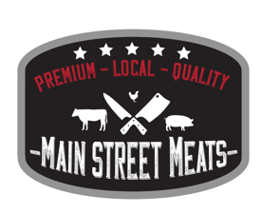
Beef Cutting Instructions

Customer Name: | Date:
Phone: | Hot Hanging Weight:
Email:
Address: | (Circle) Whole or Half
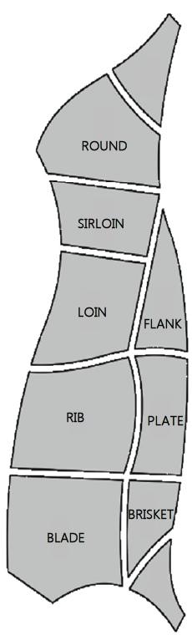

Round | Roast / Steaks
Sirloin | Roast / Steaks
Loin (T-Bone) | Steaks
Rib | Roast / Steaks
Cross Rib | Roast / Steaks
Short Rib | Yes or No (Circle)
Blade | Roast / Steaks  Or Ground Beef
Brisket | Yes or No (Circle)
Stew Meat | Yes or No (Circle)  1 lb or 2 lb if yes
Soup Bones | Yes or No (Cirlcle)

Roasts – Size in lbs |  | Vac Seal / Paper Seal | Vac seal - $0.50/pk
Steaks – per pack _____ | Thickness: ½”, ¾” or 1” | Vac Seal / Paper Seal
Ground Beef weight per pack | 1 lb or 2 lb
Boneless Cuts | Yes or No |  | Additional $0.10/lb
Custom Processing – 30 lb minimum order / type
Type | Amount | Wrapping | Processing Pricing
MSM Signature Patties |  | Vac Seal/Box | $2.50/lb
Smoked Ukrainian Sausage |  | Vac Seal/Paper Wrap | $3.00/lb
Smoked Farmers Sausage |  | Vac Seal/Paper Wrap | $3.00/lb
Smoked Jalapeno Cheddar Sausage |  | Vac Seal/Paper Wrap | $3.50/lb
Fresh Sausage |  | Vac Seal/Paper Wrap | $2.75/lb
Snack Sticks |  | Vac Seal/Paper Wrap | $3.50/lb
Pork Ratio for Sausage:

