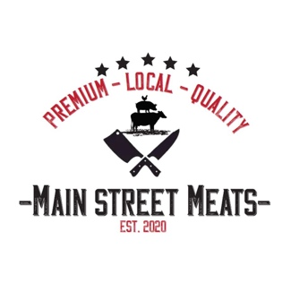
Wild Game Processing Form

Name:
Phone Number:
Type of Meat (Species):
License Number:
Hanging Weight / Amount Delivered:
Date & Received By:

Processing Instructions:
Roasts – Size |  | Vac Seal/Paper Wrap
Steaks – per pack & thickness |  | Vac Seal/Paper Wrap
Ground – weight/pack |  | Vac Seal/Paper Wrap
Custom Burgers – pork ration |  | Vac Seal/Box
Custom Processing – 30 pounds minimum orders / type
Sausage Type: | Amount: | Wrapping:
Smoked Ukrainian Sausage |  | Vac Seal/Paper Wrap
Smoked Farmers Sausage |  | Vac Seal/Paper Wrap
Smoked Jalapeno Cheddar Sausage |  | Vac Seal/Paper Wrap
Fresh Sausage |  | Vac Seal/Paper Wrap
Snack Sticks |  | Vac Seal/Paper Wrap
Smoked Cheddar Smokies |  | Vac Seal/Paper Wrap
Pork Ratio:

Processing Prices:

Cut & Wrap (Over 100 lbs)- $1.25/lb
Cut & Wrap (Under 100 lbs) - $150
Custom Grind - $0.50/lb
MSM Signature Patties - $2.50/lb
Vac Seal – $0.50/pack
Paper Wrap Included

Smoked Ukrainian Sausage - $3.00/lb
Smoked Farmers Sausage - $3.00/lb
Jalapeno Cheddar Sausage - $3.50/lb
Smoked Cheddar Smokies - $3.50/lb
Snack Sticks - $3.50/lb
Custom Fresh Sausage - $2.75/lb

*All Sausage Products are a minimum order size of 30 lbs

